Assignment 1 :- date:-05/08/2025

Question 1:_ Develop a program to calculate the shipping cost based on

the destination zone and the weight of the package (you will be provided).

Calculate the shipping cost according to these conditions:

- If the destination zone is 'XYZ', the shipping cost is $5 per kilogram.

- If the destination zone is 'ABC', the shipping cost is $7 per kilogram.

- If the destination zone is 'PQR', the shipping cost is $10 per kilogram.

- If the destination zone is not 'XYZ', 'ABC', or 'PQR', display an error message.

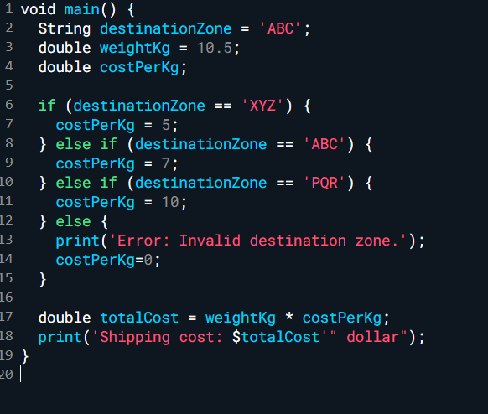



Question 2:- Suppose you often go to a restaurant with friends and need to split the bill.  
Write a program to calculate the split amount of the bill

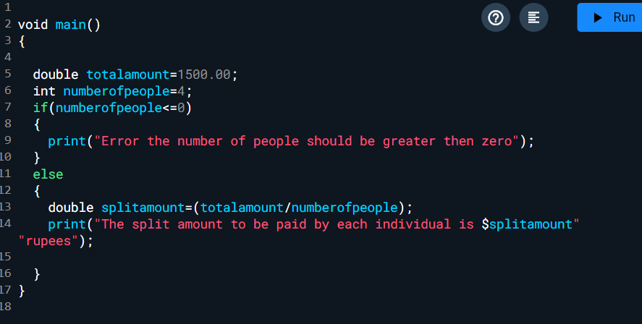



Question 3:-

Take a list, for example:  
a = [1, 1, 2, 3, 5, 8, 13, 21, 34, 55, 89]  
Write a program that prints out all the elements of the list that are **less than 5**.

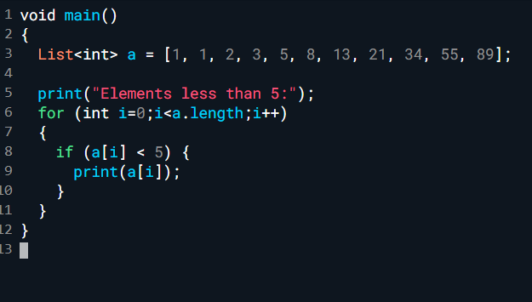



Question 4:-

Write a **Dart program** which accepts a sequence of **comma-separated numbers** from the user and generates a **list** and a **tuple** with those numbers.  
**Sample data:** 3, 5, 7, 23  
**Output:**  
List: ['3', '5', '7', '23']  
Set: ('3', '5', '7', '23')

